STAWA SET 24

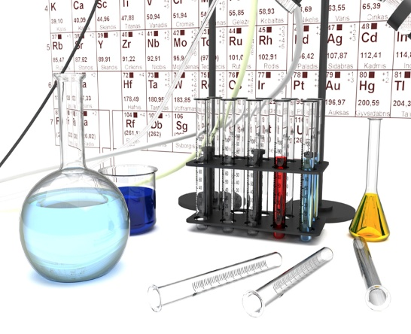

SOLUTIONS

